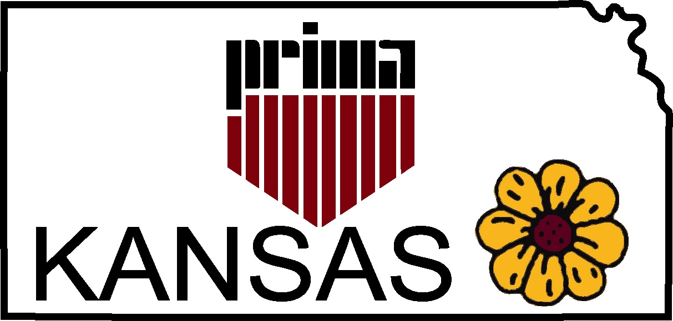Kansas Chapter
Public Risk Insurance
Management Association
http://kansasprima.org

Quarterly Meeting
Johnson County Community College
February 21, 2020 1234 College Blvd., OP, KS Carlsen Center 107 - Krebs Room 10:00 a.m. – 2:30 p.m.
Agenda
10:00 a.m. Business Meeting Call to Order & Introductions Bill Cauveren, President
Approve November Meeting Minutes Holly Ray, VP
Treasurer’s Report Dave Wimberly, Treas./ Sec.
2019 Audit Report
2020 Membership Renewal Update
- Renewals and New
- Membership Directory will be updated soon
MO/KS 2020 Conference - April 15-17, 2020- The Lodge of Four Seasons
- Navigating The Currents of Risk
- Presentations are set
- Sponsorship and Vendor participation is very good
Scholarship(s) Available

11:00 a.m. Tara Eberline and Sarah Otto
Foulston Siefkin LLP
Topic: Anatomy of a Lawsuit

Lunch 12:00 p.m. – 12:45 p.m.

1:00 p.m. Cathy Puls, VP - Workers’ Compensation Claims Leader
Lockton Companies LLC
Topic: Recent Developments and Topics - Workers’ Compensation

2:00 p.m. Business Meeting Conclusion
2020 Officer Nominations
IA/NE/SD-Conference-update (Sid)
New Business
Announcements
Other/Open Agenda

NEXT QUARTERLY MEETING DATE: May 15, 2020 – Topeka KASB Office

2:30 p.m. Adjournment.

REGISTER ONLINE - https://kansasprima.wildapricot.org/
Questions: Holly Ray, Miami County, KS
(913) 294-9530
hray@miamicountyks.org

