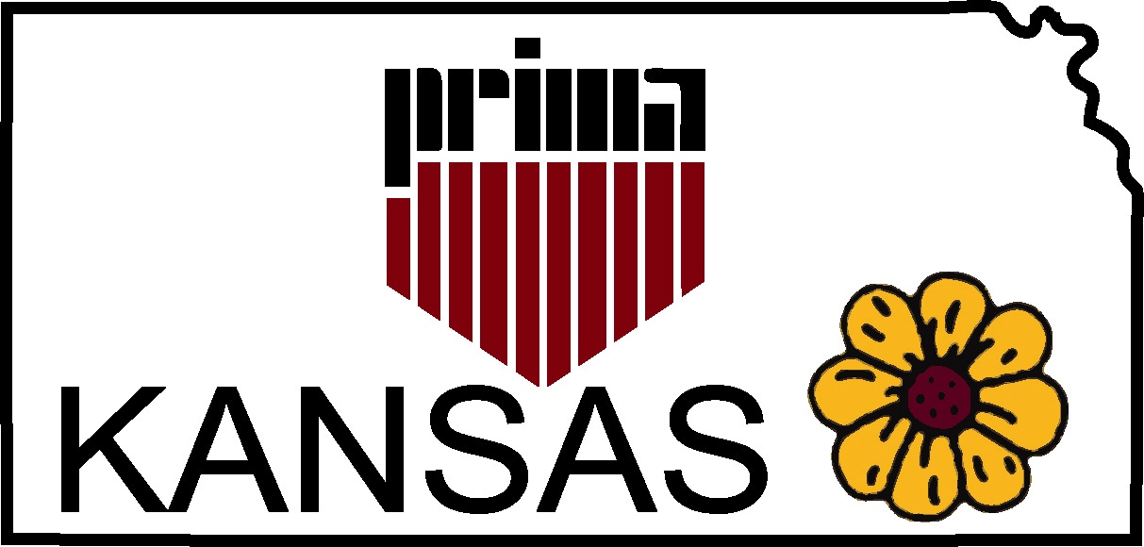F
Public Risk Insurance
Management Association
http://kansasprima.org

Quarterly Meeting Johnson County Offices
February 15th, 2019 111 S. Cherry St., Olathe, KS 66061
10:00 a.m. – 2:30 p.m. Lower Level Rm #202/204
Agenda
10:00 a.m. Business Meeting Call to Order & Introductions Donna Capria, President
Approval Meeting Minutes Bill Cauveren, VP
Presentation of Treasurer’s Report
Audit Report
MO/KS Conference 2019-Lodge of Four Seasons, April 10-12TH, 2019 (scholarships)
Committee Members: Sponsorship, Entertainment, Speakers, Golf

10:30 a.m. Speaker Introduction
Vaughn Baker, Strategos International
Topic: “Seconds Count-When Lockdown Fails!”

Lunch 12:00 p.m. – 12:30 p.m.

12:30 p.m. Business Meeting Conclusion
Nominating Committee
2019 National Conference-ORLANDO, June 9TH-12TH (scholarships)
MAY 17TH MEETING-UNIFIED GOVERNMENT OF WYANDOTTE COUNTY
AUGUST MEETING-LOCATION
FALL ED DAY-2020
Issues, Challenges and Concerns
Announcements
Other/Open Agenda
FUTURE QUARTERLY MEETING DATES:
May 17th, August 23RD, November 15th.

2:30 p.m. Adjournment.

REGISTRATION FORM
The following people will attend the Kansas PRIMA Quarterly Meeting:

1. 3.

2. 4.

Make checks payable to Kansas PRIMA and return registration to:
Holly Ray
Miami County, Kansas
201 S. Pearl, Suite #200
Paola, KS 66071
hray@miamicountyks,org (913-294-9530)

Registration fee includes refreshments and lunch. Fees: $15.00 in advance; $20.00 at the door.

