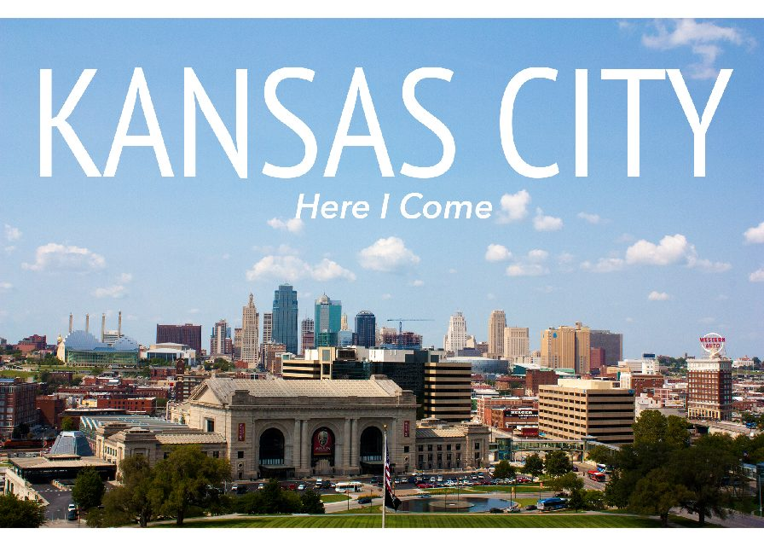
SAVE THE DATE

Here We Come

SEPTEMBER 19, 20 & 21, 2021
IA NE SD & KS PRIMA Conference

